**SQL ASSIGNMENT**

**Part A: Data Retrieval (Basic SELECT )**

Creation of database and tables:

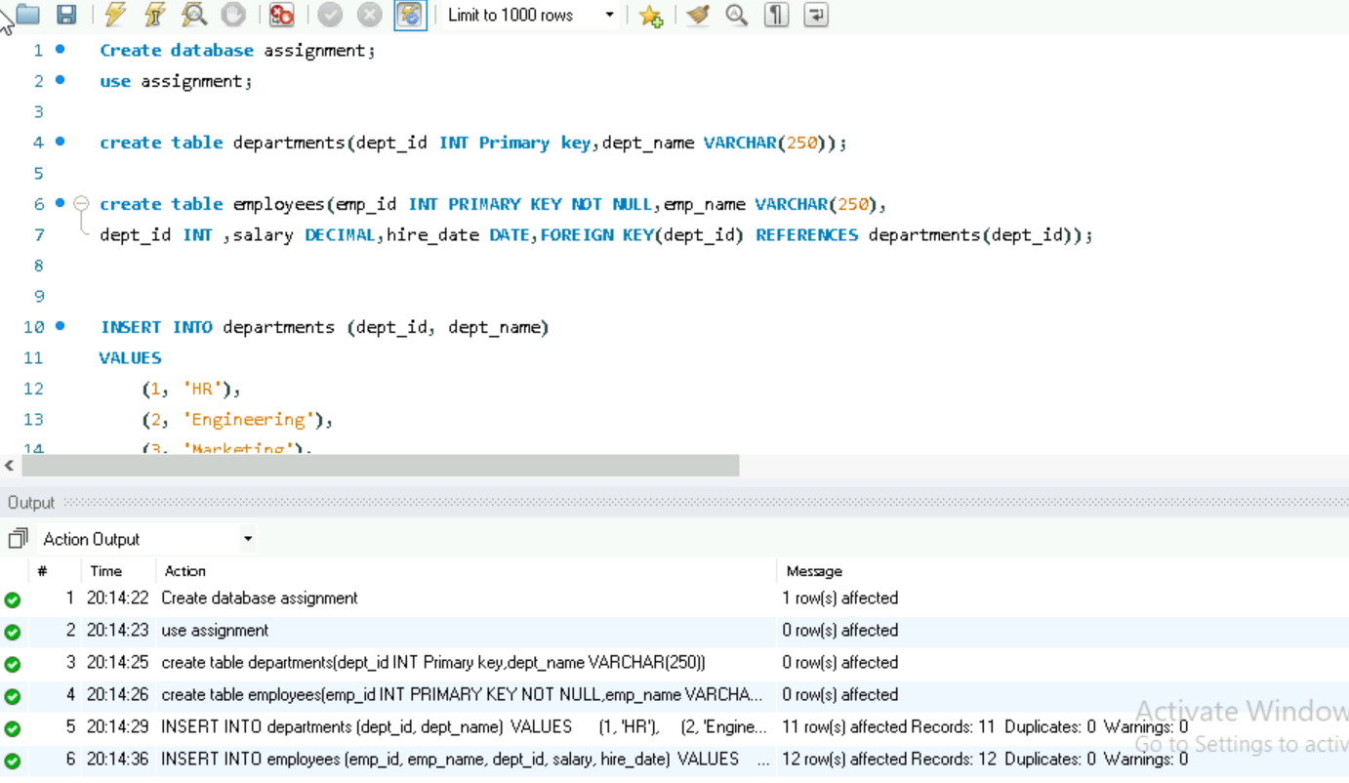

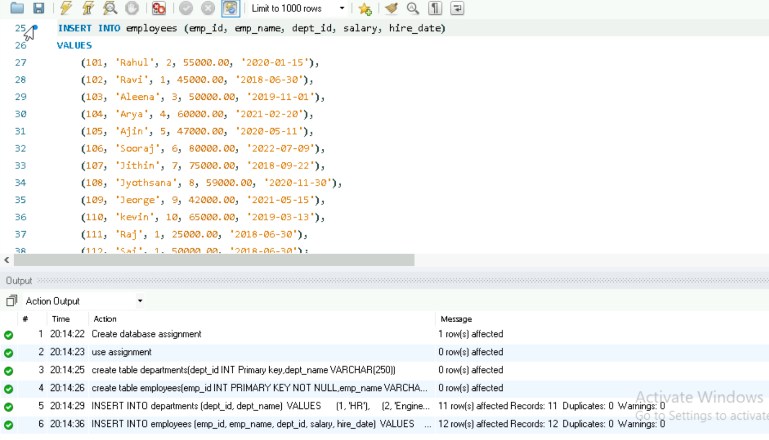

1. Write a query to display all data from the employees table.

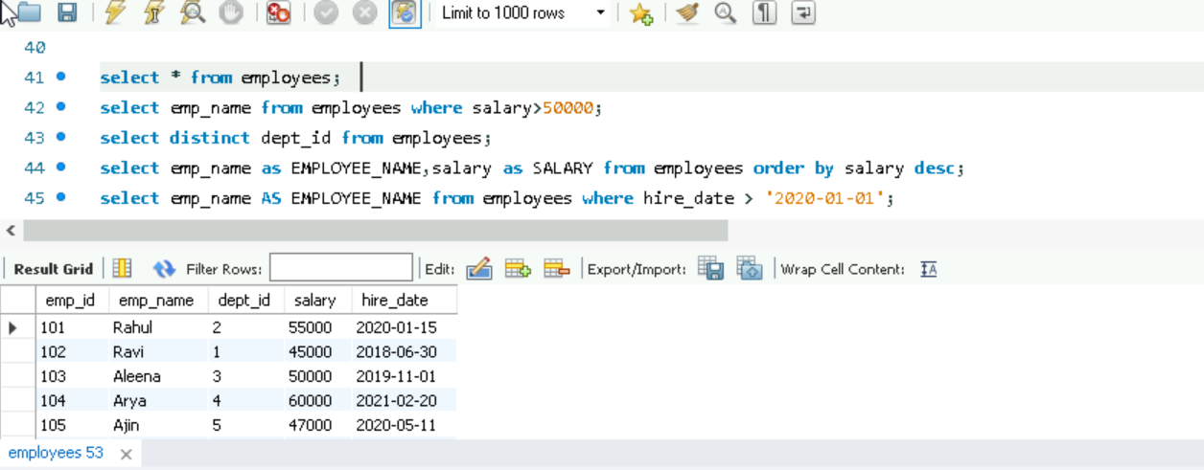

2. Show the names of employees who earn more than 50,000.

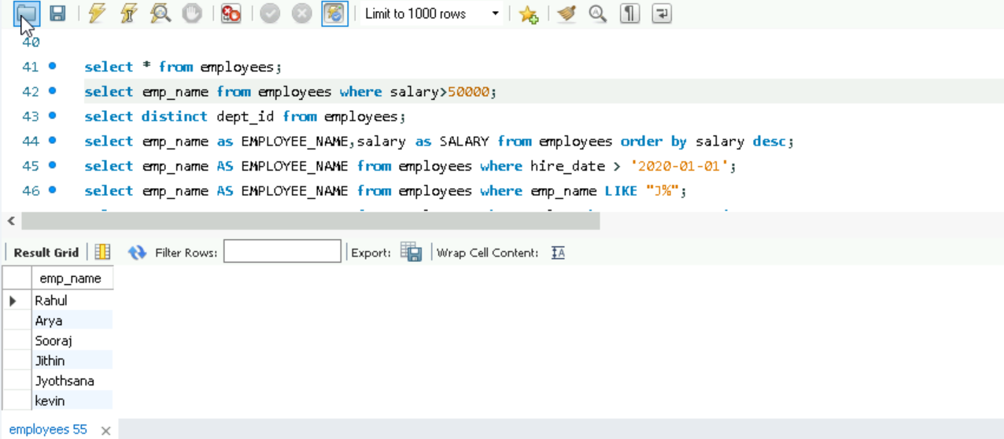

3. Retrieve the list of unique department IDs from the employees table.

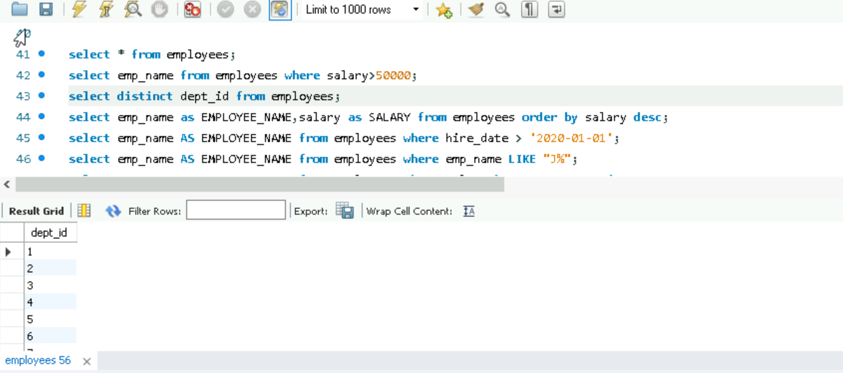

4. Display employee names and salaries sorted by salary descending.

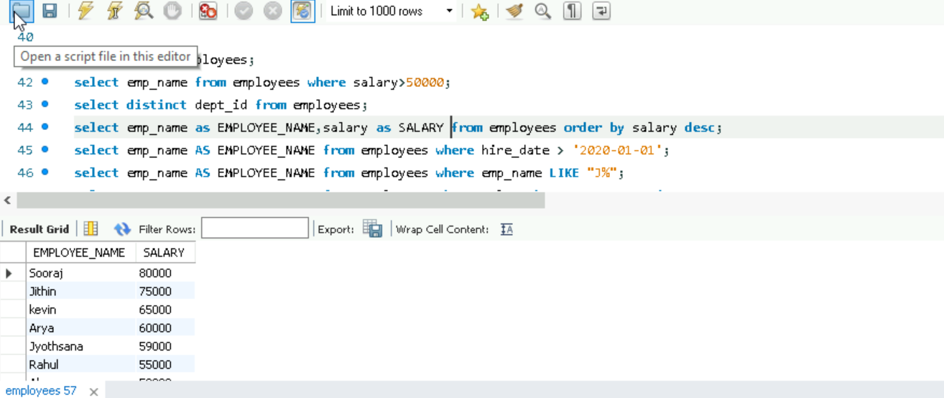

5. Find all employees hired after January 1, 2020.

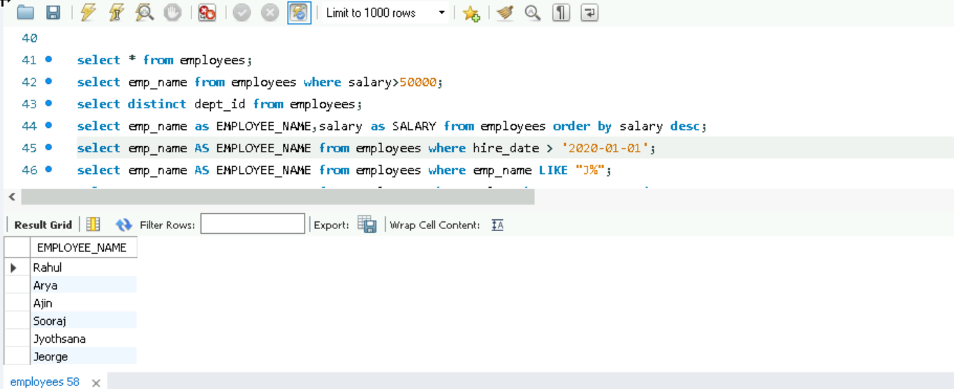

**Part B: Filtering & Pattern Matching**

6. Find employees whose names start with 'J'.

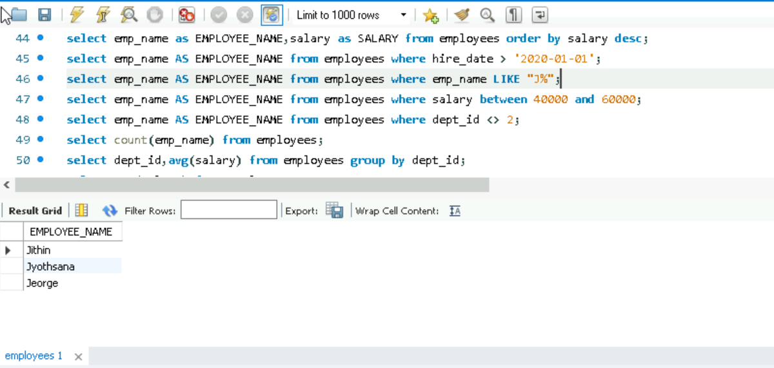

7. Get all employees with salary between 40,000 and 60,000.

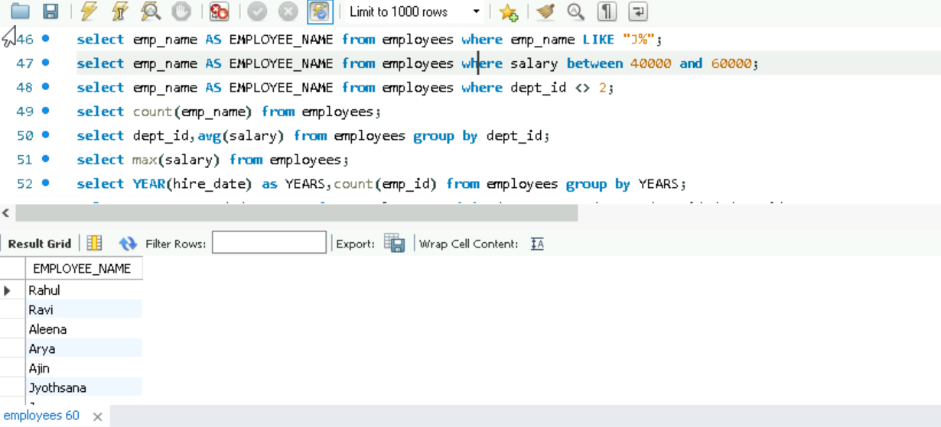

8. Show employees who do not belong to department ID 2.

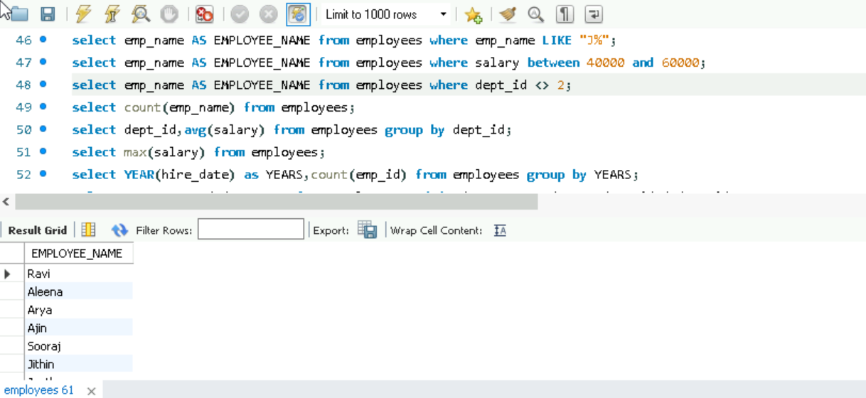

**Part C: Aggregations**

9. Find the total number of employees in the company.

10. Show the average salary in each department.

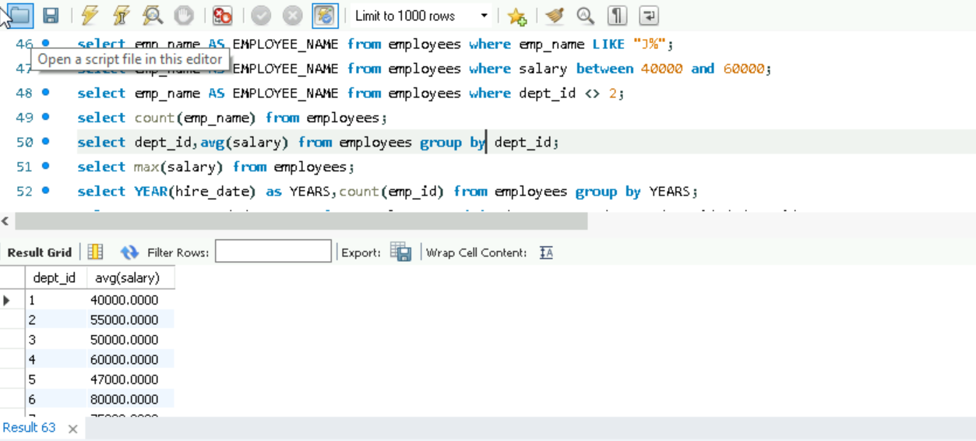

11. Find the highest salary in the employees table.

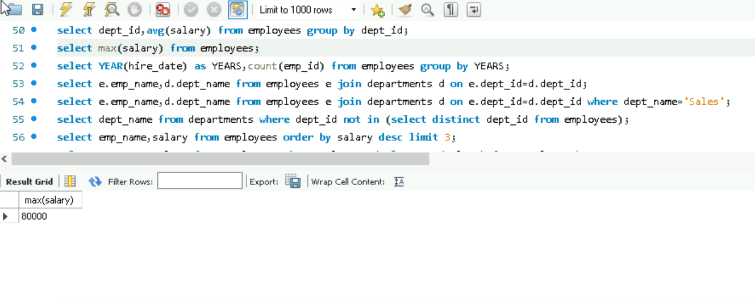

12. Count how many employees were hired in each year.

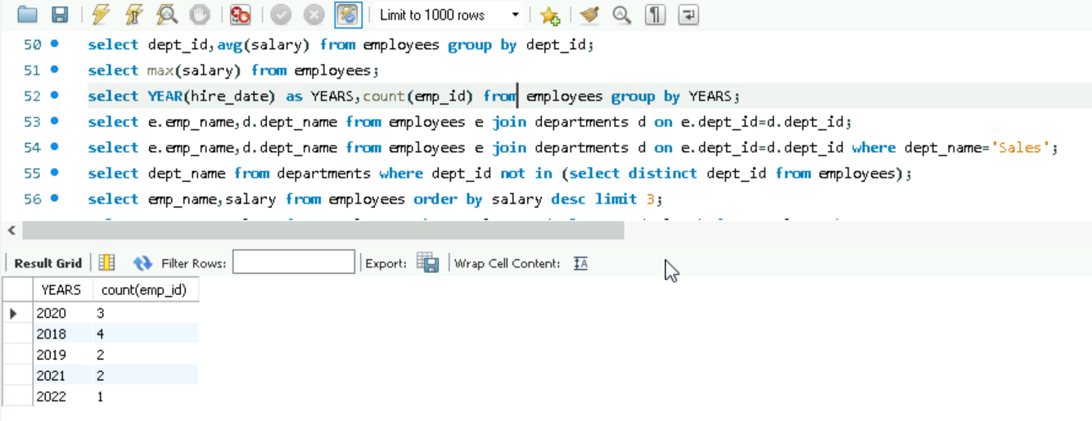

**Part D: Joins**

13. Write a query to display employee names along with their department names.

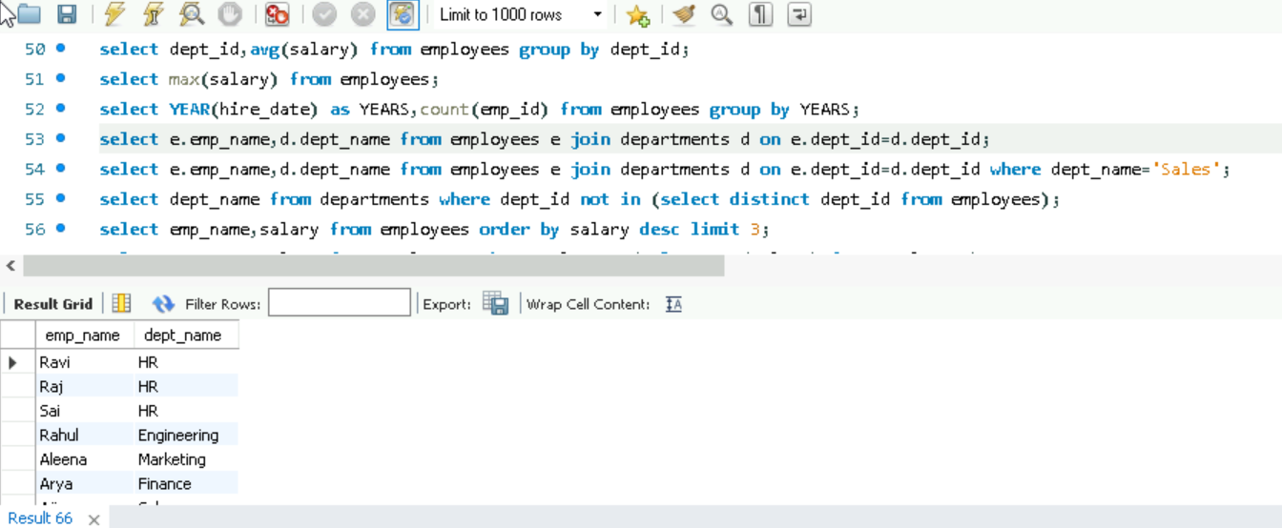

14. Find all employees working in the 'Sales' department.

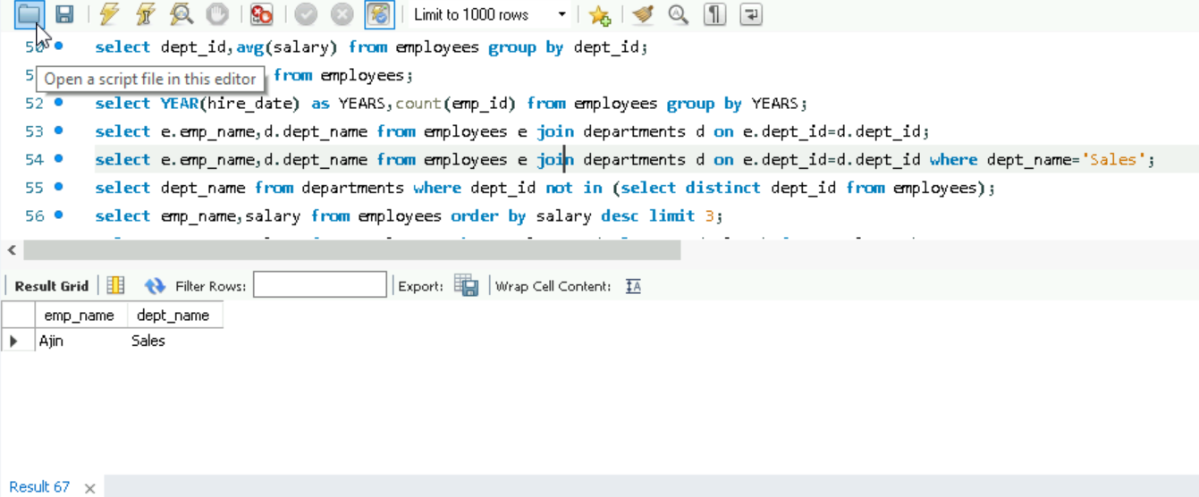

15. Last departments with no employees.

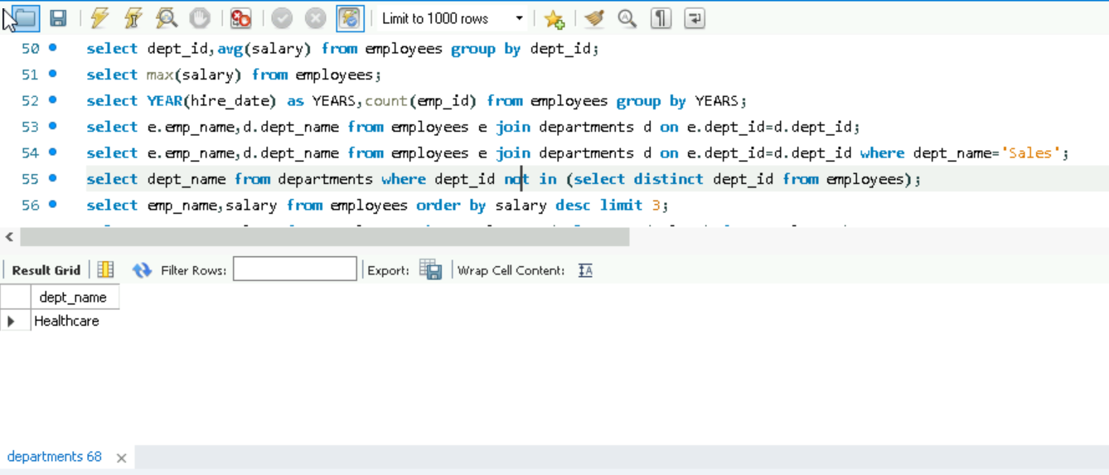

**Part E: Subqueries**

16. Find the name(s) of employee(s) with the highest salary.

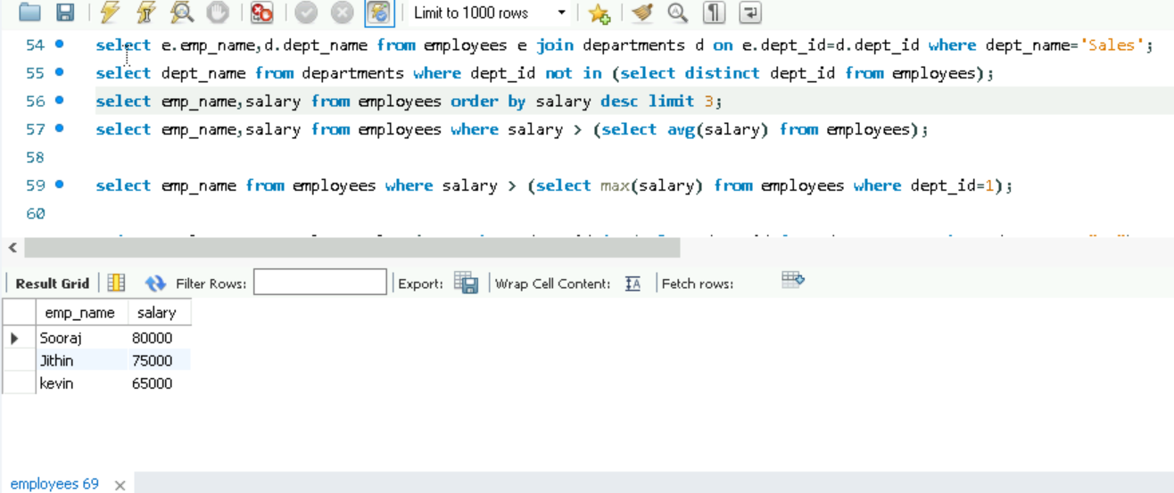

17. List employees whose salary is above the average salary of all employees.

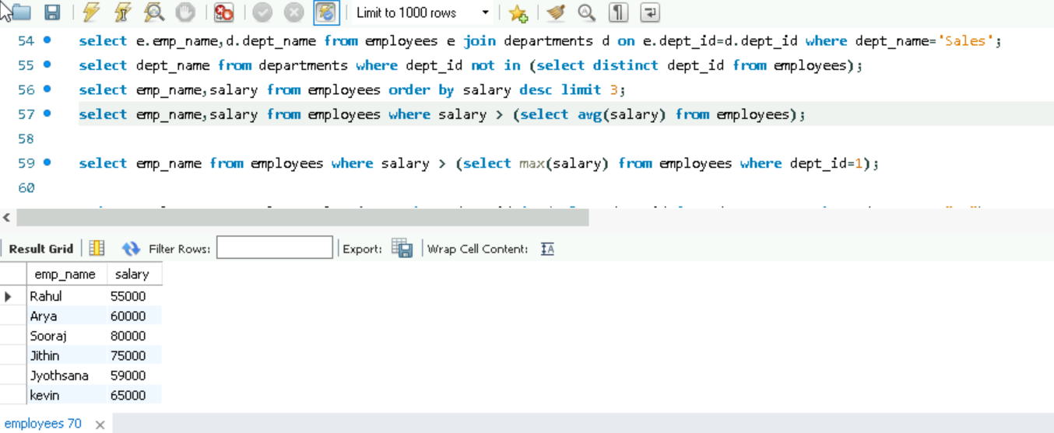

18. Show employees who earn more than the maximum salary in department ID 1.

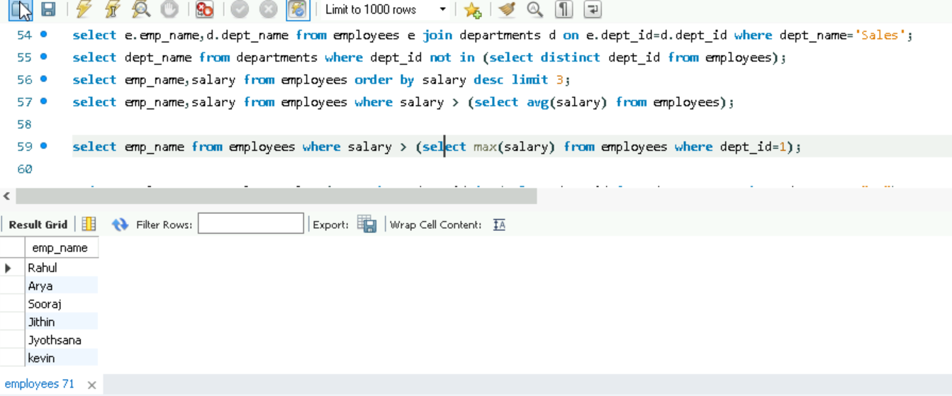

**Part F: DML (Data Manipulation)**

19. Update the salary by 10% for employees in the 'HR' department.

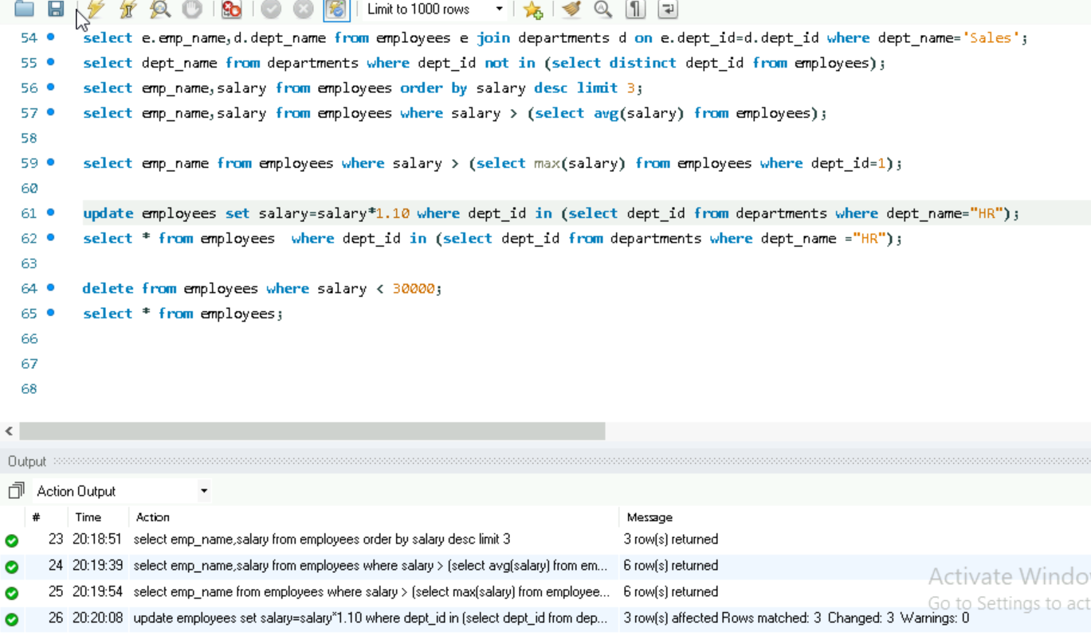

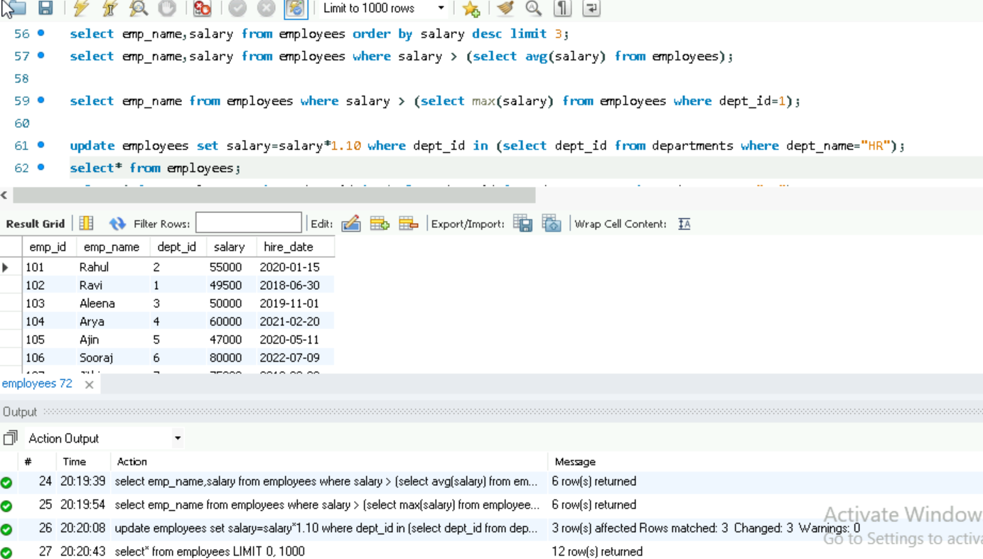

20. Delete employees who have a salary less than 30,000.

